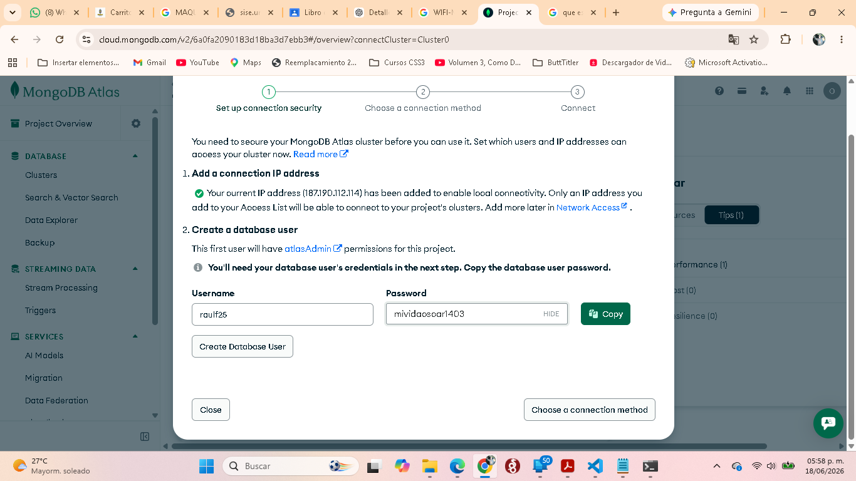

mongodb+srv://<db_username>:<db_password>@cluster0.ffhlgow.mongodb.net/?appName=Cluster0

